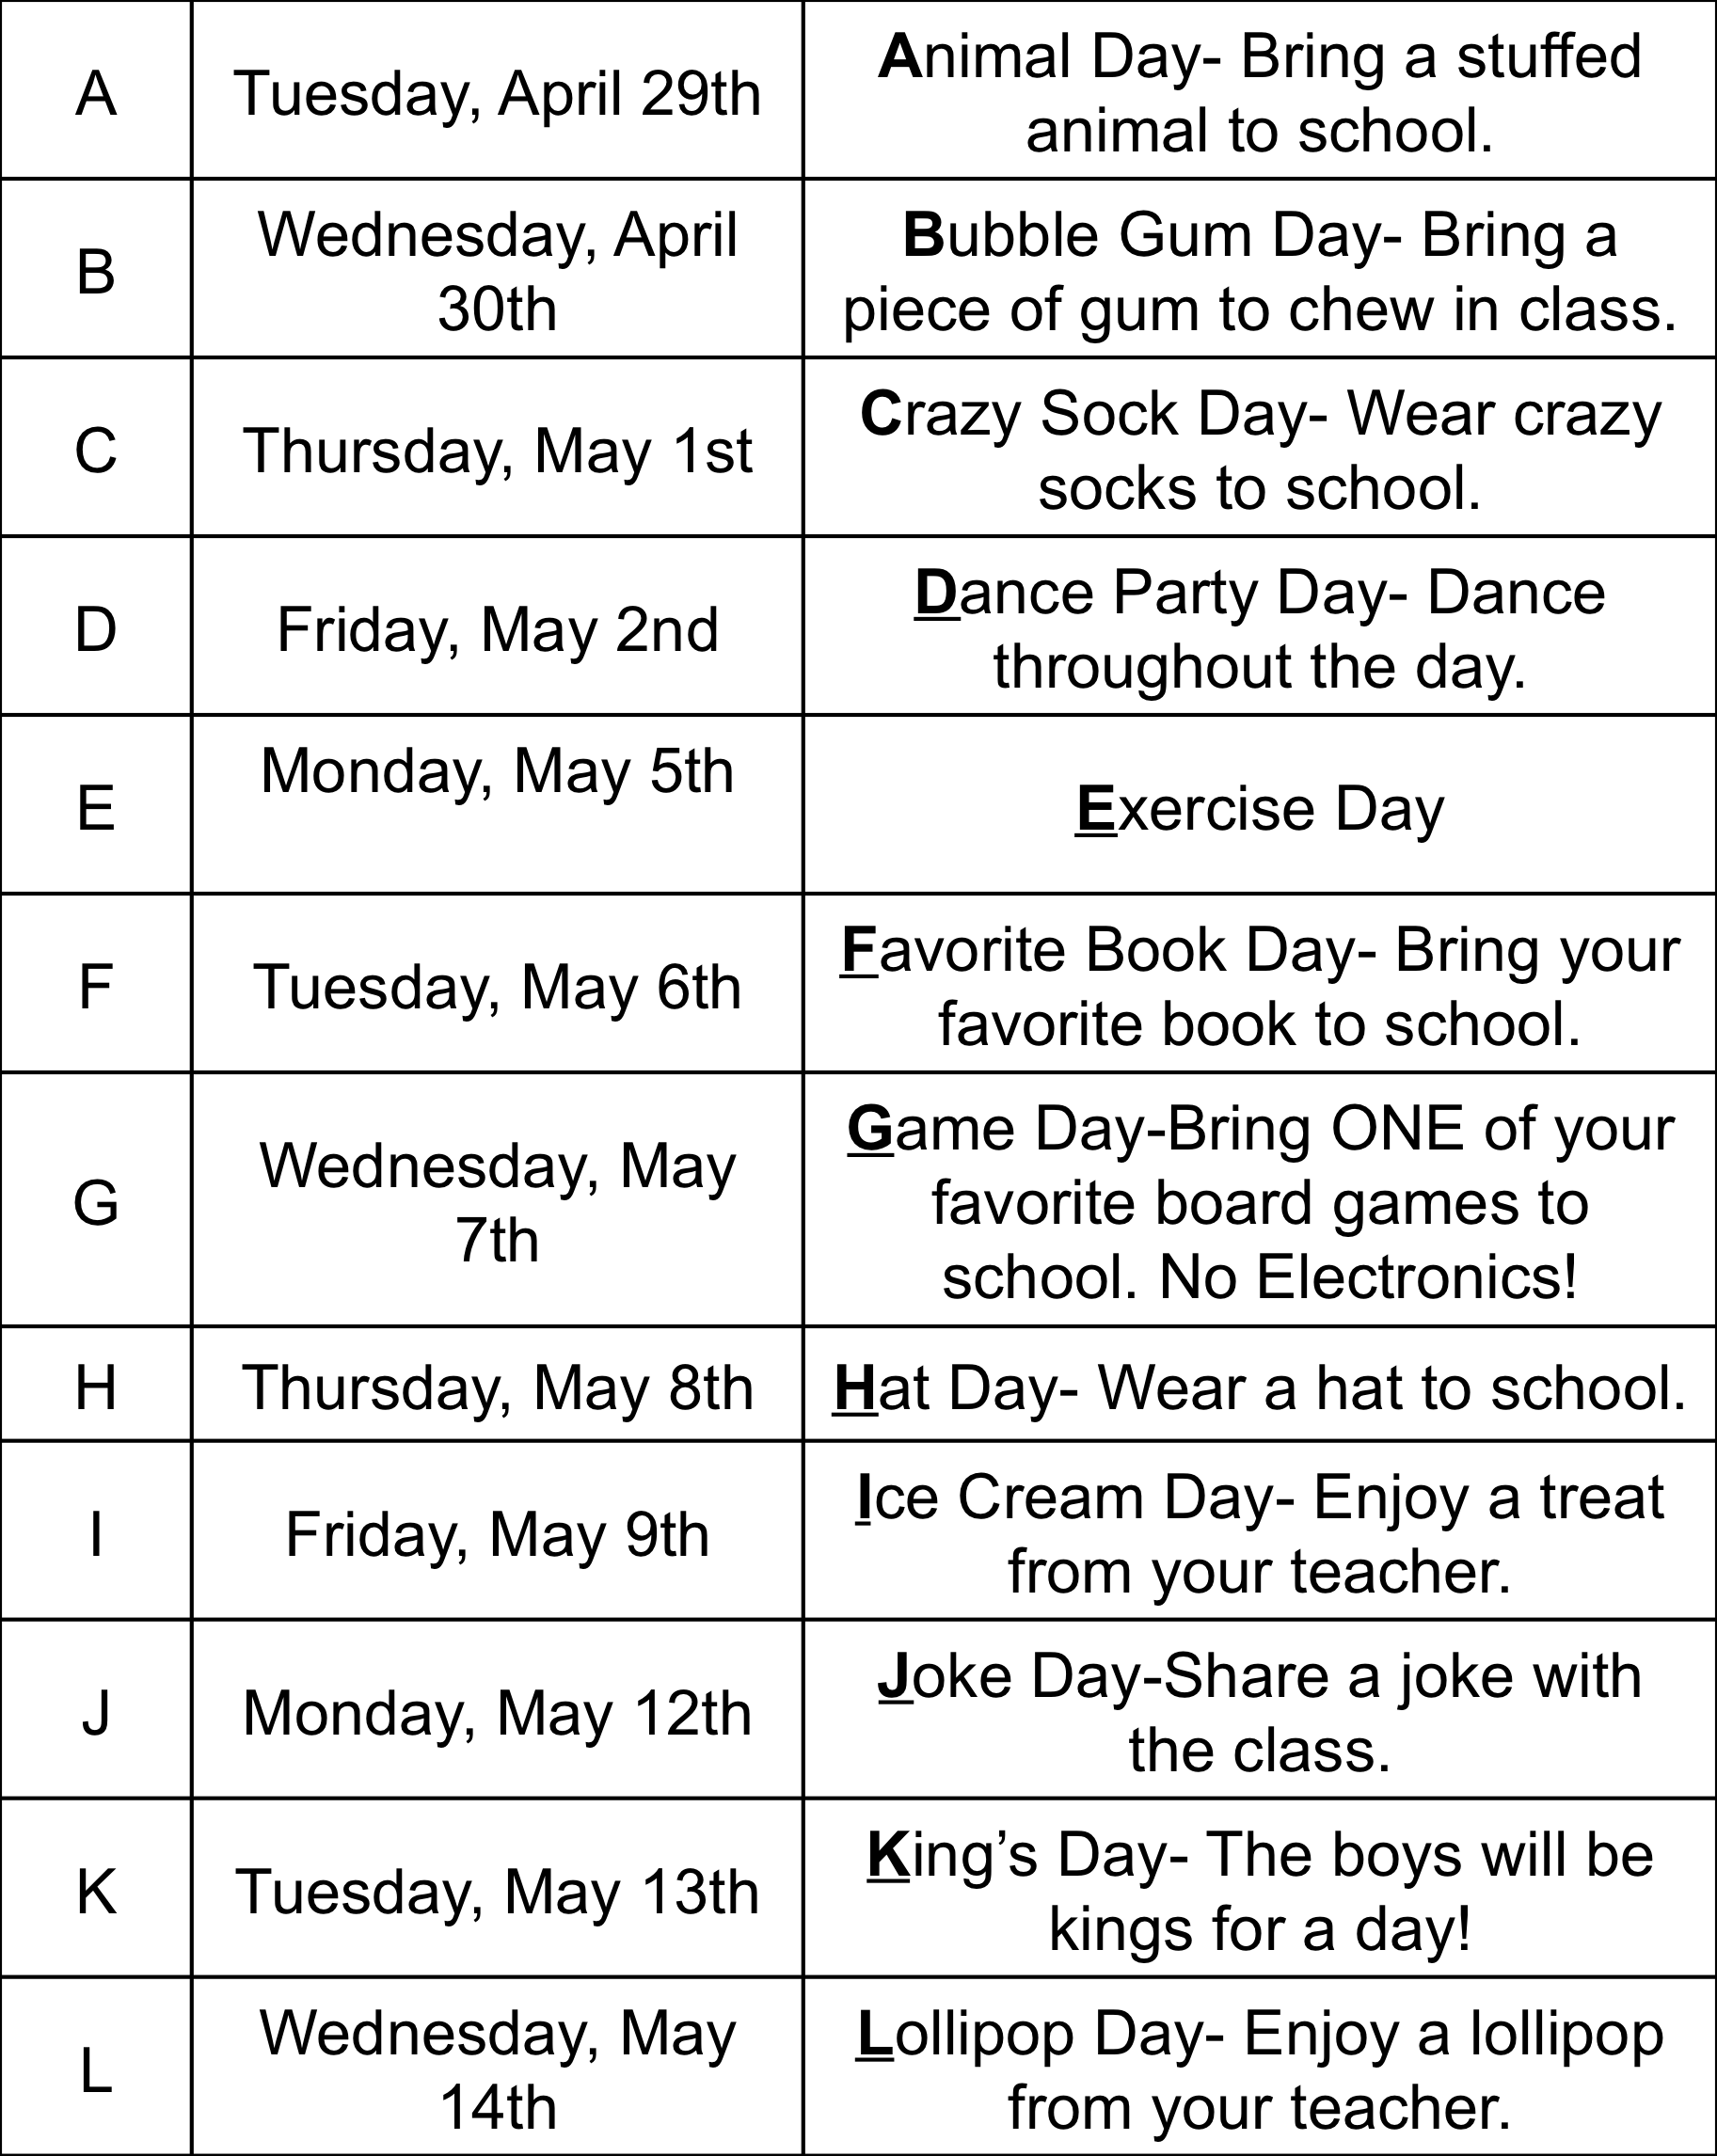
ABC Countdown!

M | Thursday, May 15th | Music Day- We will listen to music throughout the day.
N | Friday, May 16th | Necklace or Necktie Day
O | Monday, May 19th | Outside Snack Day- We will eat our snacks outside.
P | Tuesday, May 20th | Pajama Day- Wear your pajamas to school.
Q | Wednesday, May 21st | Queen’s Day- The girls will be the queens for the day.
R | Thursday, May 22nd | Rainbow Day- Wear your favorite color of the rainbow.
S | Tuesday, May 27th | Sports Day- Wear your favorite sports team apparel.
T | Wednesday, May 28th | T-shirt Day- Wear your favorite t-shirt.
U | Thursday, May 29th | Uno Day- We will play Uno under our tables. If you have an Uno game, please bring it to school.
V | Friday, May 30th | Video Day- We will watch a video.
W | Monday, June 2nd | Westgate Day- Wear your Westgate spirit wear.
X | Tuesday, June 3rd | eXtra Recess Day
Y | Wednesday, June 4th | Year End Clean Up Day
Z | Thursday, June 5th | Zip Your Bag & Enjoy Your Summer!!

